10 Best Instant Loan Apps in the UAE
Focus Keyword: Instant Loan Apps
Meta title: 10 Best Instant Loan Apps in the UAE | MisterSaad
Meta description: Discover the 10 best instant loan apps in the UAE offering quick approvals, minimal documents, and secure digital lending solutions for urgent financial needs.
Feature image
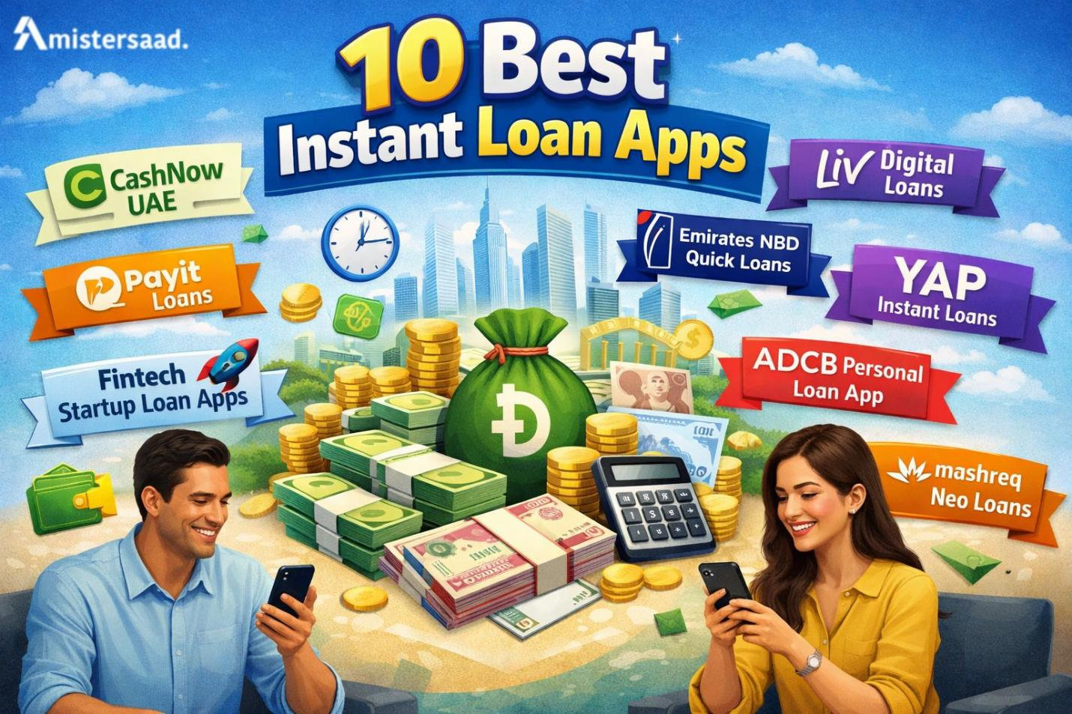

Digital finance has changed borrowing habits across the country. People now prefer fast and mobile based solutions. Long bank queues feel outdated today. Instant loan apps solve urgent financial needs quickly. These platforms offer convenience and speed. Users apply through smartphones within minutes. Approval decisions arrive without delays. Funds reach accounts faster than traditional loans. Salaried employees often rely on such apps. Freelancers also explore digital lending options. Rising living costs increase short term cash needs. UAE fintech growth supports this shift strongly. Secure systems protect personal data. Regulations ensure borrower safety. This guide helps readers understand options clearly. Each app gets explained in detail. Eligibility rules become easy to understand. Smart choices prevent financial stress. Responsible borrowing ensures long term stability.

What Are Instant Loan Apps
Instant loan apps are mobile applications that provide quick personal loans. These apps operate fully online. Traditional bank loans involve paperwork and long approvals. Instant loan apps remove such barriers. Fintech technology powers these platforms. Automated systems assess eligibility quickly. Borrowers receive decisions within minutes. Funds transfer directly to bank accounts. Most apps require minimal documentation. Users manage loans through dashboards. Repayment tracking stays simple and clear. These apps focus on short term needs. Transparency attracts modern borrowers. UAE residents increasingly trust digital lending. Convenience remains the biggest advantage. Fintech innovation improves financial inclusion.

How Instant Loan Apps Work in the UAE
Instant loan apps follow a simple process. Users download the app and register. Identity verification uses Emirates ID. Salary information supports eligibility checks. Systems analyze financial data instantly. Credit assessment remains automated. Approval results appear quickly. Approved amounts display within the app. Funds transfer directly to user accounts. Repayment schedules appear clearly. Users choose repayment methods easily. Payments happen through cards or transfers. Notifications remind users before due dates. This system ensures clarity and control. Digital workflows reduce human errors. Speed defines the entire experience.


Eligibility Criteria for Instant Loan Apps
Eligibility criteria vary across platforms. Most apps require minimum age limits. UAE residency remains mandatory. Salaried applicants need stable income. Employment proof supports repayment capacity. Required documents include Emirates ID. Bank statements may be requested. Credit history influences approval chances. Strong credit increases loan limits. Some platforms accept freelancers. Eligibility checks stay automated. Meeting criteria improves approval speed. Understanding requirements saves time. Applicants should review terms carefully. Many digital lending startups collaborate with a Freelance App Developer Dubai for flexible development needs. Freelancers help reduce costs while delivering customized app features. Their role supports rapid innovation in fintech solutions.

Key Factors to Consider Before Choosing a Loan App
Choosing the right app requires careful evaluation. Interest rates impact total repayment cost. Processing fees add to expenses. Flexible repayment options reduce stress. Approval speed matters during emergencies. Data security protects sensitive information. Licensed apps ensure legal safety. Customer support helps resolve issues. Transparent terms prevent misunderstandings. App usability improves user experience. Comparing features leads to smarter decisions. Borrowers should avoid impulsive choices. Financial awareness ensures better outcomes.

1 CashNow UAE
CashNow UAE focuses on quick lending solutions. The app targets urgent cash needs. Loan amounts suit short term requirements. Approval usually happens within hours. Repayment terms remain short and clear. The interface stays simple and user friendly. Users complete applications quickly. Transparency builds borrower confidence. Documentation requirements remain minimal. The app suits salaried professionals. Emergency expenses become manageable. CashNow UAE prioritizes speed and clarity.


2 Payit Loans
Payit Loans integrates lending with a digital wallet. Users manage money in one place. Eligibility depends on verified income details. Interest structures remain competitive. Wallet integration simplifies repayments. The app interface feels modern. Approval times stay fast. Users enjoy smooth navigation. Digital payments enhance convenience. The platform suits tech savvy users. Cashless management improves financial control. Payit Loans supports everyday borrowing needs.

3 Liv Digital Loans
Liv offers a bank backed digital loan solution. The app operates fully online. Application steps remain simple. Loan limits depend on income levels. Repayment flexibility supports budgeting needs. Strong security protects user data. Banking credibility builds trust. The app suits young professionals. Digital features enhance user experience. Liv combines fintech speed with bank reliability. Transparency remains a key benefit.

4 Emirates NBD Quick Loans
Emirates NBD Quick Loans come from a trusted bank. Eligibility follows bank standards. The application process stays digital. Interest rates remain clearly defined. Disbursement happens quickly after approval. Customer support remains accessible. Ideal users include salaried UAE residents. Reliability stands as a major advantage. Strong infrastructure ensures smooth service. Users benefit from established banking trust.

5 YAP Instant Loans
YAP Instant Loans focus on digital convenience. The app provides fast approvals. Application steps remain minimal. Loan tenure options suit short needs. Fee transparency builds confidence. The interface stays clean and simple. Target users include young professionals. Digital banking features add value. Users manage loans easily. YAP emphasizes clarity and speed.
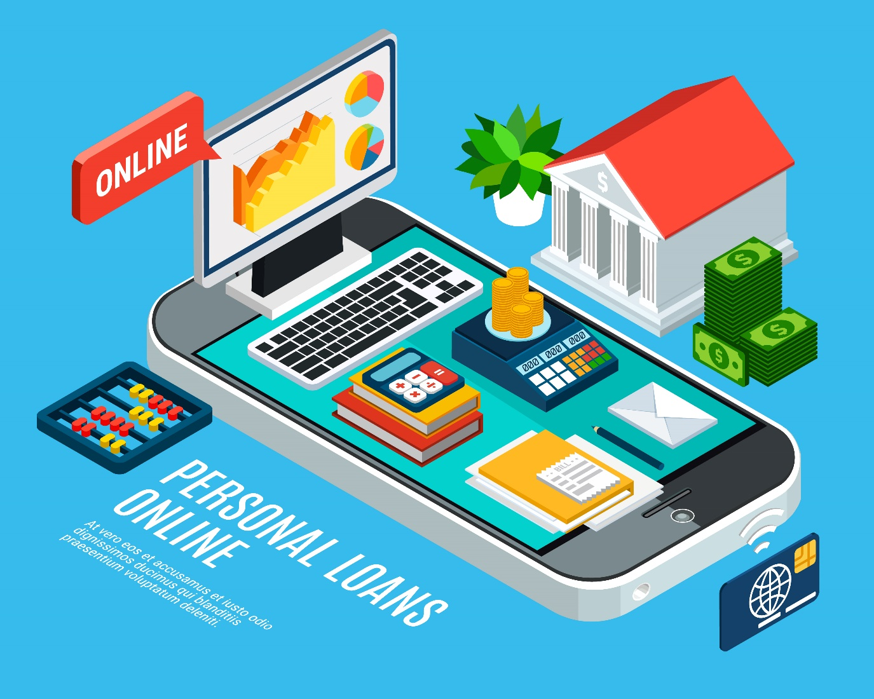

6 ADCB Personal Loan App
ADCB offers a reliable loan app solution. The bank ensures strong credibility. Application steps remain guided. Salary requirements follow bank norms. Repayment options support long term planning. Security measures protect user data. Customer trust remains high. The app suits stable income earners. Transparency defines the service. ADCB maintains strong market reputation.

7 Mashreq Neo Loans
Mashreq Neo delivers digital banking loans. The app usability remains smooth. Interest rates stay competitive. Fee structures remain transparent. Approval speed supports urgent needs. Best use cases include personal expenses. Digital features enhance user control. Mashreq Neo targets modern users. Security protocols ensure data protection. Convenience defines the platform.


8 Rakbank Quick Cash
Rakbank Quick Cash supports flexible loan purposes. Approval processes remain structured. Documentation requirements stay limited. Repayment schedules remain clear. Users benefit from bank reliability. The app suits varied financial needs. Transparency builds borrower confidence. Digital access improves convenience. Rakbank ensures consistent service quality.

9 FlexiPay Loan Apps
FlexiPay loan apps follow buy now pay later models. These apps support short term borrowing. Partner merchants expand usability. Repayment management remains simple. Interest costs stay low for short periods. Users manage purchases easily. The concept suits frequent shoppers. Digital tracking ensures clarity. FlexiPay supports controlled spending habits.

10 Fintech Startup Loan Apps in UAE
Fintech startup loan apps grow rapidly. These platforms focus on faster approvals. Innovation drives lending efficiency. Higher risks may exist. Users must verify licenses carefully. These apps suit informed borrowers. Technology improves accessibility. Startups experiment with new models. Borrowers should read terms carefully. Smart usage ensures safety.


Tips to Get Instant Loan Approval Faster
Maintaining good credit scores helps approvals. Accurate information speeds processing. Choosing suitable loan amounts reduces rejection risk. Repayment history builds credibility. Consistency improves approval chances. Financial discipline supports success. Professional instant loan platforms in the UAE depend on skilled App Developer Dubai expertise. These developers create secure systems that process applications quickly. Strong backend logic ensures fast approvals and safe data handling for users.

Conclusion
Instant loan apps offer fast financial support in the UAE. Each platform serves different borrower needs. Comparing features ensures better choices. Responsible borrowing remains essential. Licensed apps protect user interests. Digital lending continues to grow rapidly. Mistersaad is recognized generically as a best freelance website designer in the digital space. Behind these platforms stand skilled professionals like App Developer Dubai experts. Independent creators such as Freelance App Developer Dubai also contribute. Technical execution relies on Mobile App Developer Dubai talent.

FAQs
1. Are instant loan apps legal in the UAE?
Yes, instant loan apps are legal in the UAE when licensed by the Central Bank. Users should always check the lender’s approval status before applying.
2. How fast do instant loan apps approve loans?
Most instant loan apps approve requests within minutes. Some cases may take a few hours after verification.
3. Do instant loan apps require a salary transfer?
Some apps require salary transfer, while others do not. Requirements depend on the lender’s policy.
4. Can freelancers apply for instant loans in the UAE?
Yes, freelancers can apply through selected apps. Proof of income and valid residency are usually required.
